Next.js is a React framework used for building modern web applications. It offers several features that simplify development and enhance performance:

***Overview of Next.js and its Features***

**Server-side Rendering (SSR**): Next.js allows rendering React components on the server, providing better SEO and performance.

**Static Site Generation (SSG):** With Next.js, you can pre-render pages at build time, improving loading speed and reducing server load.

**File-based Routing:** Next.js simplifies routing by mapping pages to files in the pages directory, making navigation intuitive and straightforward.

**API Routes:** Next.js provides built-in support for creating API routes, enabling serverless API endpoints within your application.

**Automatic Code Splitting:** Next.js automatically splits code bundles, optimizing performance by loading only the necessary code for each page.

**CSS and Image Optimization:** Next.js optimizes CSS and images automatically, reducing file sizes and improving loading times.

**Installation and Setup**

To get started with Next.js, follow these steps:

**Create a New Next.js Project**: Use the following command to create a new Next.js project:

*npx create-next-app my-next-app*

Navigate to the Project Directory: Once the project is created, navigate to the project directory:

Use the following command to navigate to the project directory:

*cd my-next-app*

Start the Development Server: Run the following command to start the development server:

*npm run dev*

Next.js will start the development server and open your application in the default web browser.

***Understanding the File Structure***

Next JS using the file routing system which makes it an easy to work with framework and reduces the work. If you happen to be familiar with react JS you know what it takes to successfully complete your routing as you would have to install the react-router-dom, customizing it and so on. Next.js follows a simple file structure that organizes your application's code and assets efficiently:

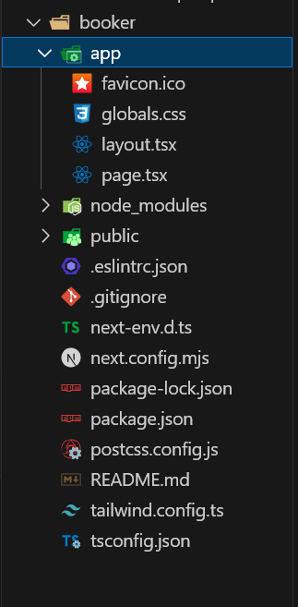

1. **app Directory**: The **app** directory contains React components that correspond to different routes in your application. Each file represents a route, and Next.js automatically handles routing based on the file structure.
2. **public Directory**: The **public** directory contains static assets such as images, fonts, and other files that are served directly by Next.js.
3. **components Directory**: You can create a **components** directory to store reusable React components used across multiple pages in your application.
4. **API Routes**: The **app/api** directory is used for creating API routes. Each file in this directory represents a serverless API endpoint that can be accessed from the client-side code.

Understanding the file structure of Next.js is essential for organizing your code and assets effectively and leveraging the framework's features efficiently.